CPSC 478/578 Computer Graphics

Fall 2015

Assignment #1

Assigned: Wednesday, September 2, 2015

Due: Thursday, September 17, 2015, 11:59pm

(This is the day after shopping period ends, no extensions for being a late shopper.

Results will be discussed in lecture on Monday, September 21, 2015.)

**This assignment has four questions. Note that the requirements for each question may vary depending on whether you are registered for 478 or for 578. The areas addressed in this assignment are the structure of images, and defining and displaying triangles using WebGL.**

**Turn-in Procedure**

You should submit your work as a zip file using the classesv2 server. Please name your file as

LastNameFirstName-Assignment1.zip

When your file is unzipped there should be subdirectories for each question named q1, q2, q3, q4 and q5. Name your files as directed in each question. In each directory you should have:

1. The HTML and Javascript programs you have written. You should use files in the form of the samples given, rather than producing files from scratch. This will help us follow your code.

2. Sample images created by your program. You can save these by clicking and saving results in your browser, or by taking a screenshot.

3. A readme.{txt, doc} that answers any questions posed, and that lists the input used to create the images you include. You should also list the operating system (e.g. Linux, Windows 7, 8.1, 10, Mac OS 10.4.4) and browser (e.g. Firefox 40.0.2, Safari, IExplorer, Edge) that you used. If you programs fail on the machines used for grading, you may be asked to bring in your system to demonstrate that the files you submitted functioned in the environment you worked in.

**Question I.** Creating and displaying an image using html and Javascript.

**478 and 578** The file q1-example.html uses the script js/onmycanvas.js to create an image and assign colors to the image pixels. This shows you how you can address each pixel, and what the effect of combining values of r,g, and b are. Use the file q1-sinewave.html and modify js/sinewave.js to create a script that displays sine waves of colors in the horizontal and vertical directions. Use the values entered in html to determine how many cycles of the sine wave and the colors of the brightest point in the cycles. Screen shots below show sample output. Your results do not have to be pixel-by-pixel the same as the sample screen shots, but the basic number of cycles and the colors should be the same. Make use of Math.sin() in Javascript.

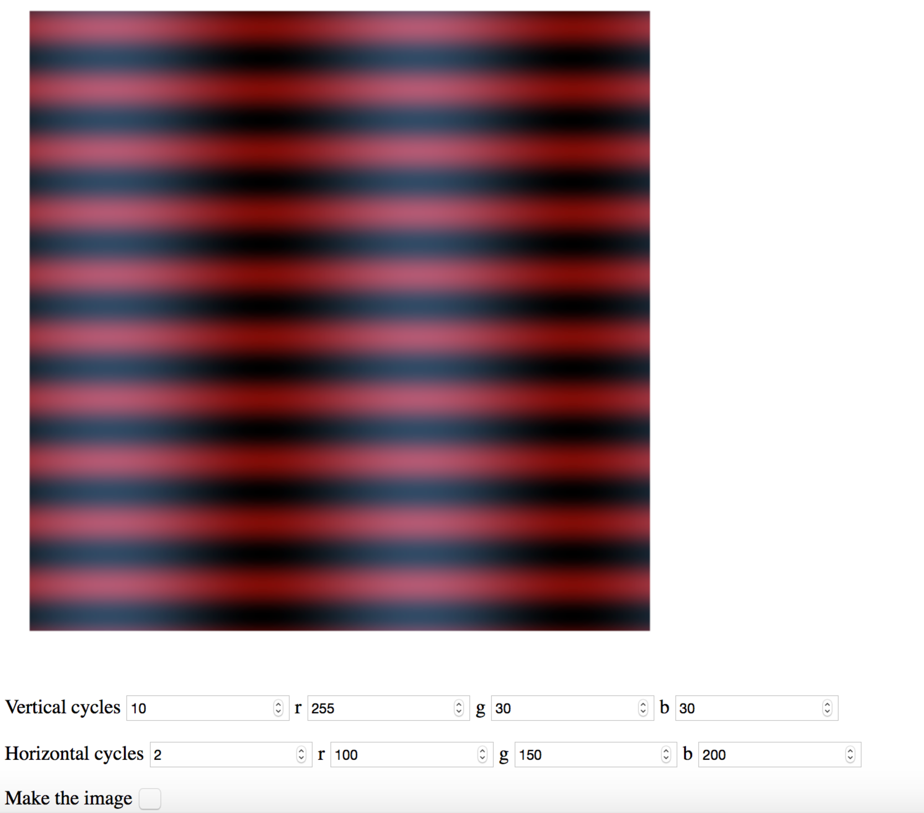

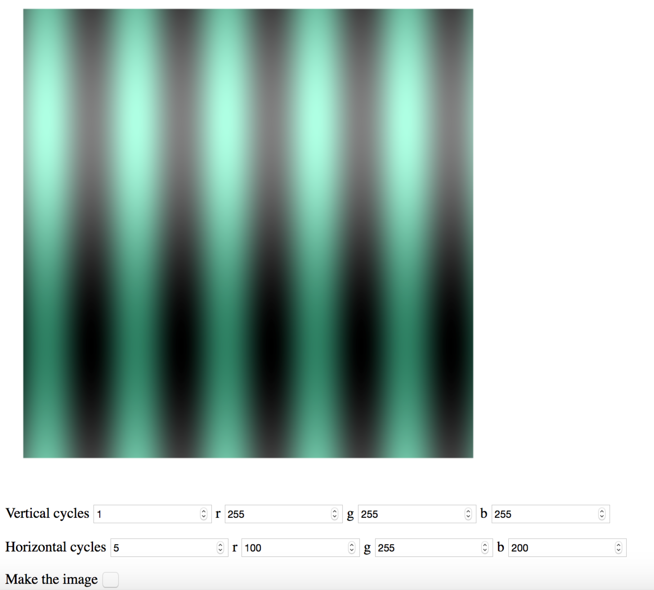

**578** Use some other analytical functions based on image location (e.g. polynomials, exponentials) to vary color across the image to make new abstract designs. Select some different parameters (rather than cycles) to control the result. Name your files q1-other.html and js/other.js

**Question 2.** Reading and filtering an image using html and Javascript.

**478 and 578** The file q2-example.html and js/filtering.js show how to browse for an image and then display the original image and the image after filtering. In this case the filter is very simple – the green and blue channels are changed. Create new files q2-bilateral.html and js/bilateral.js that take two integers in addition to browsing for a file. The first integer n should specify the size of a box filter. That is, if n is 2 each pixel (i,j) in the filtered image should be the average of the 25 pixels from (i-2,j-2) to (i+2,j+2). The second integer m should specify an intensity matching value from 0 to 255. For each pixel calculate an intensity (.3r+.5g+.2b). The box filter should be calculated by only including pixels in the sum that have an intensity within m of the pixel value of (i,j). If m is 255, all of the pixels should be used. If m is 0, a pixel will be the average of other pixels with the same intensity. In the readme file for this question, explain the visual effect of changing n and m.

**578** Write a new filter that displays an image that shows the absolute value of the difference between the original image and an image filtered with a box filter of size m. Explain what features of the original image this new image shows.

**Question 3.**  Drawing a line, pixel by pixel.

**478 and 578** Create a new html file q3-line.html that takes as input the value of two points p1= (x1,y1) and p2= (x2,y2), and an image size nhorizontal and nvertical. The values of the x’s and y’s should all be between 0 and 1. Write a script js/bresenham.js that draws a line from p1 to p2, considering the lower left hand corner of the image as (0,0), and the upper right hand corner as (1,1). Draw the line using Bresenham’s algorithm. Alternate the colors of the pixels along the line between blue and red. DO NOT use WebGL and DO NOT use any built in “draw” functions.

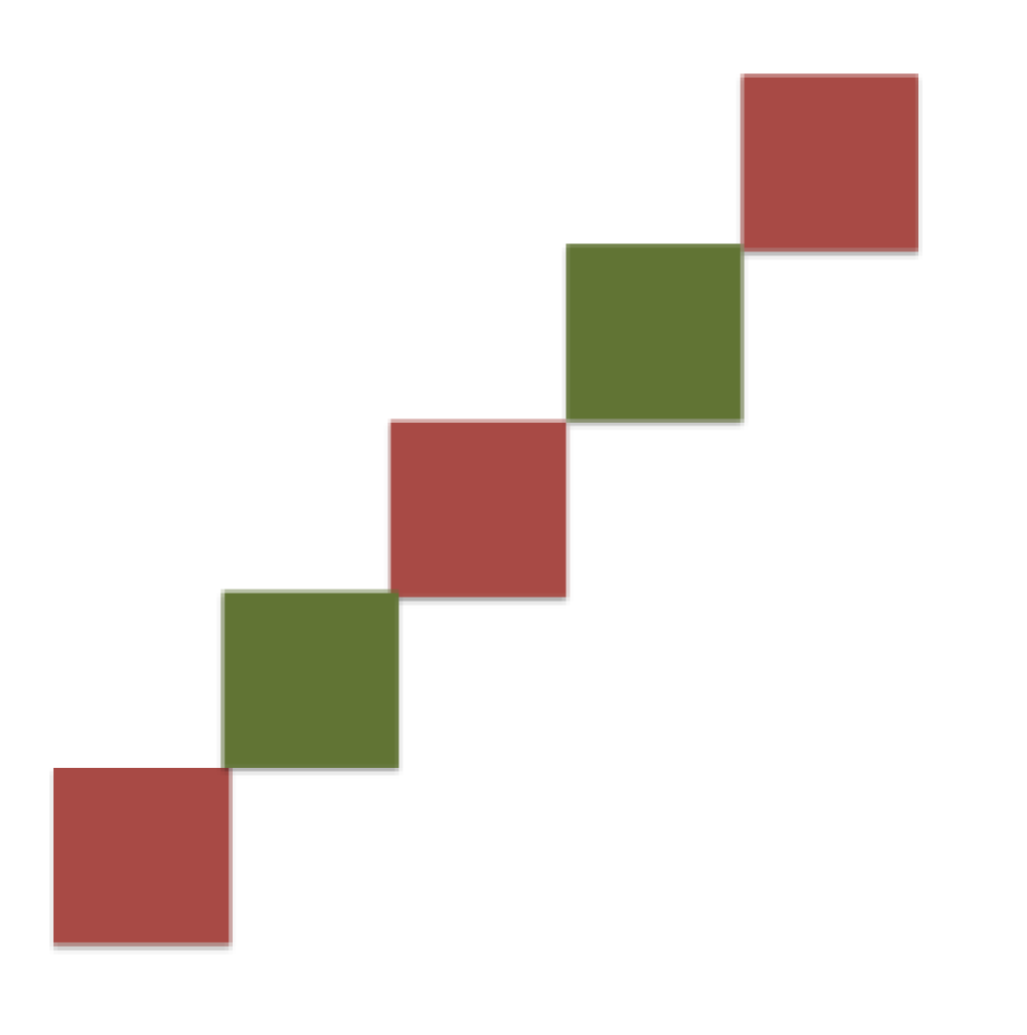Example of a line draw pixel by pixel with alternating colors.

**578** Create a new html file q3-triangle.html that takes as input three points p1,p2, p3, in the same form as in the first part of question 3. Create a file js/triangle.js that draws the three lines that form a triangle. In the readme file, describe how drawing these lines could be used to efficiently draw a filled triangle (i.e. a triangle where all of the pixels inside the triangle are some color other than the background).

**Question 4.** Uniformly colored traingles in WebGL.

**478 and 578** The file hello_draw_another.html is a variation of the file hello_draw.html that is part of the code provided with the Ganovelli et al. textbook. Write a new file hello_draw_ten_random.html that draws 10 random triangles. (Hint: use Math.random() and a loop to specify the random coordinates.) Running your file multiple times should result in triangles that land in all four quadrants of the image (not just the upper right, or not just the top of the image). The images below are examples from my implementation. You do not have to get the same pixel-by-pixel results. You can choose your own two colors for background and triangle color.

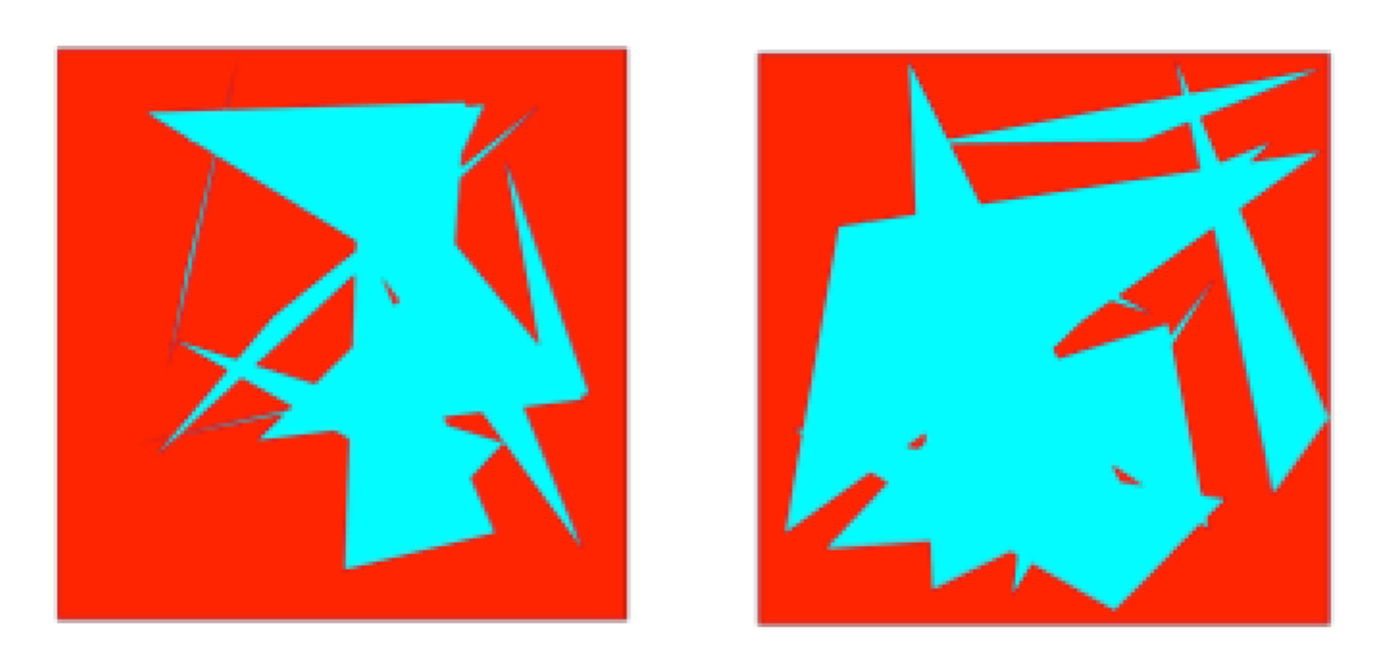

**Question 5.** Triangles with many colors in WebGL

**478 and 578** The files rendering-variation.html and js/rendering-variation.js are variations of files provided with the Ganovelli et al. textbook. Write your own files q-filled-circle.html and js/rendering-filled-circle.js that produces a filled circle approximated by n triangles that either has each triangle filled with a different uniform color (like a beach ball) or which has one color in the middle that smoothly varies to second color at the edges. Your html file should let the user specify how many triangles are used in the approximation, whether the solid colors or smoothed colors are used, and which colors are used.

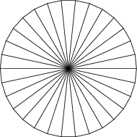A circle approximated by triangles.